QUIZ 2 / Units 5 - 8 /
Name:__________________________________

1.Match.
a boy, a monkey, elephants, a tiger, a bike,


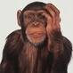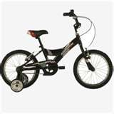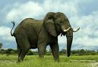

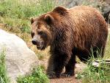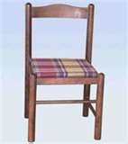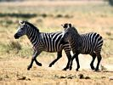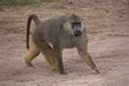

zebras, a bear, monkeys, a chair, an elephant,

2. Write: It ’ s or They ’ re.
10 points

________________ zebras. _____________________ a bike.
________________ a boy. ___________________ elephants.
________________ tigers. ___________________ a chair.
6 points

3. Ask and answer.
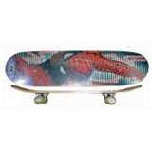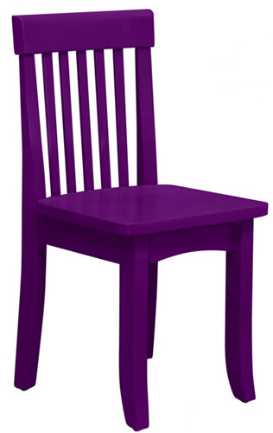
What are these? ___________________ ___________________
They ’ re skateboards. ____________________ ____________________



What ’s this? __________________ __________________
It ’ s a house. ______________________ ______________________

4 points

4. Write: Yes, it is.; No, it isn’t.; Yes, they are.; No, they aren’t.;
Is this an umbrella? 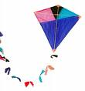 ___________________________________________
Are these windows?  ______________________________________
Is this a table?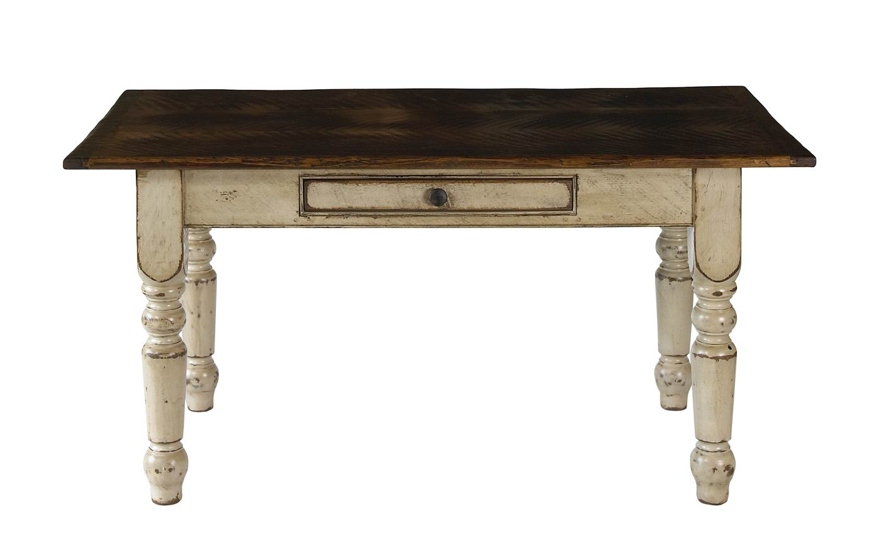__________________________________________________
Are these dolls? __________________________________________
4 points

5. Ca n you guess what colour I am? Write colours.

elub-……………………….. leowly-…………………………
enreg-………………………… hwiet-…………………………..
rde-…………………………… yger-……………………………

6. Count animals, then write.
6 points
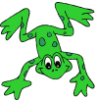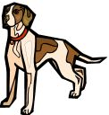

How many frogs?...................................How many elephants?................................

How many dogs?................................. How many cats?........................................

4 points

Total :
34 points

